**Project Initialization and Planning Phase**

| Date | 23/6/24 |
| --- | --- |
| Team ID | SWTID1720100721 |
| Project Name | Machine Learning Approach To Predict Price of Natural Gas |
| Maximum Marks | 3 Marks |

**Define Problem Statements (Customer Problem Statement Template):**

Create a problem statement to understand your customer's point of view. The Customer Problem Statement template helps you focus on what matters to create experiences people will love. A well-articulated customer problem statement allows you and your team to find the ideal solution for your customers' challenges. Throughout the process, you’ll also be able to empathize with your customers, which helps you better understand how they perceive your product or service.

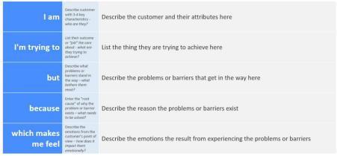

Reference: https://miro.com/templates/customer-problem-statement/

**Example:**



|  |  |  |  |  |  |
| --- | --- | --- | --- | --- | --- |
| **Problem**  **Statement (PS)** | **I am**  **(Customer)** | **I’m trying to** | **But** | **Because** | **Which makes me feel** |
| PS-1 | A Natural Gas Buyer | Predict the future price of Natural Gas | I am unable to get accurate predictions | Current models are inaccurate or too complex | I feel uncertain about future gas prices and unable to make informed purchasing decisions. |
| PS-2 | A Natural Gas Seller | Predict future gas prices to make informed selling decisions | I struggle to accurately predict future prices | Traditional methods are unreliable and time-consuming | Uncertainty about future profitability and potential financial losses |